School Supply List
2nd Grade
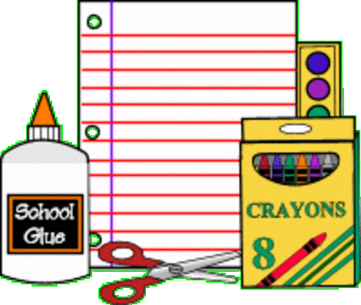
- 3 pocket folders
- 1 ruler (inches/centimeters)
- 1 pencil pouch zippered
- 2 kid scissors
- 2 boxes of 24 crayons or colored pencils
- 2 boxes of sharpened pencils
- 10 glue sticks
- 8 wide ruled marble composition pads
- 6 thin dry erase markers
- Block erasers
- Post-it notes
- Highlighters
- Homework assignment pad
- Pocket notepad (to store log-in information and passwords)

