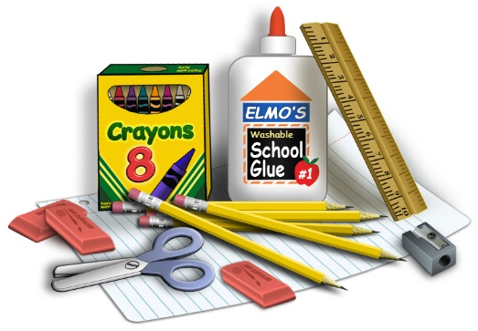
Fifth Grade Supplies

Math - Social/Studies
2 subject notebook (math)
1 subject notebook (SS)
marble composition notebook (math)
1 graph notebook
3 folders
6 pencils

All Subjects
1 yellow highlighter
1 black sharpie
1 sharpener with cover
1 pair of student scissors

ELA/Science
1- 5 subject notebook (ELA)
1 marble notebook ( Science )
2 -1 subject notebooks ( Writing and Science)
1 pocket folder
6 pens ( black or blue )

