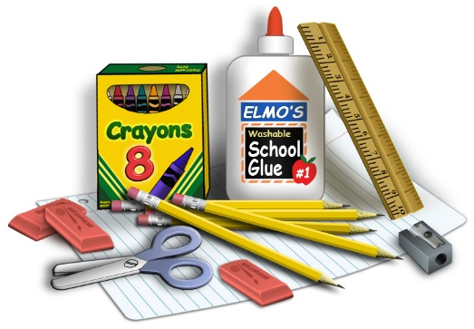
First Grade Supply List

- 4 pocket folders (plastic preferred for durability)
- Box of pencils
- Erasers
- 2 boxes of Crayola crayons (no more than 24 count)
- 5 notebooks (no spirals)
- Dry Erase Markers (at least 4)
- Small scissors
- Box of tissues
- Bottle of hand sanitizer or Baby wipes

